 | Francotyp-Postalia
Windows IOT - Install PostBAse Driver
# | Version | Date | Authors | Comments/Modifications
 | 1.0 | 26.08.2016 | Kai Nicolai | initial revision

This document describes the steps to install PostBase drivers on Windows IOT (i.e. Raspberry Pi). This guid is based on tutorials found here
https://developer.microsoft.com/en-us/windows/iot/samples/driverlab3
and a Stackoverflow question here
http://stackoverflow.com/questions/33317743/winusb-driver-on-windows-10-iot

Transferring Driver Files Using SMB
First, boot up your Windows 10 IoT Core device and make a note of its IP Address as displayed on its attached screen when the device first boots up.
Next, on your development PC, open up a File Explorer window, and in the address bar type \\<TARGET_DEVICE>\C$\ and then hit enter. In this particular case, <TARGET_DEVICE> is the IP Address of your Windows IoT Core device:
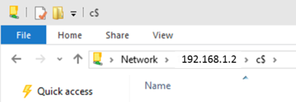
Enter you login credentials
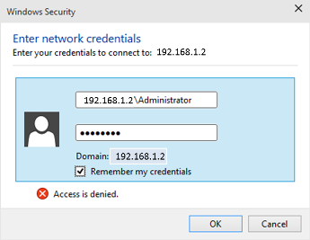
Navigate to a folder where you would like to copy your files to. We are using a tool to install the drivers so the location does not really matter.
Drag and drop (copy) the driver files (serial_usb_phoenix.inf and if a signed driver is used serial_usb_phoenix.cat) into the folder
The next steps involve connecting to the target device using PowerShell through the IOT Dashboard. Make sure you have an active PowerShell connection to your Windows 10 IoT Core device.

Installing the sample driver
Using the PowerShell window, navigate to the directory containing your driver files on the target device.
We will use the devcon.exe tool to install the sample driver. Type the following command in the PowerShell window:
devcon.exe dp_add serial_usb_phoenix.inf

Check the Status Of The Sample Driver
Connect any running postbase machine to the IOT device. From the PowerShell window, type the following command:
devcon status USB\VID_2311*
You should see the following output, depending on the postbase model the PID value may vary:
USB\VID_2311&PID_0501\1
Name: USB Serial Device
Driver is running.
1 matching device(s) found

